**Challenge #4**

Our business users in Adventure Works Cycles are country managers. Country manager is responsible for making marketing decisions, forecast product demand and recommend new products based on customers profile.

1. Secure the data set such that the country managers should only see their country specific information in reports, dashboards. Define few security roles in Power BI desktop

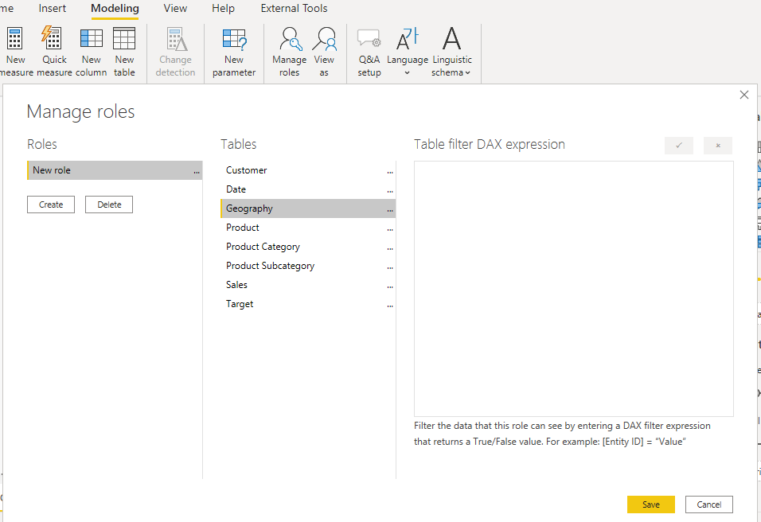

**Workspace**

1. Login to Power BI service (<https://app.powerbi.com>)
2. Create a new workspace “Adventure Works Cycles “ + Your Employee ID. 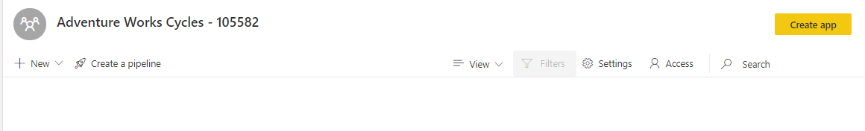
3. Publish the report from Power BI desktop to the above workspace. View the relationship between the dataset and report using Lineage view

**Dataset**

1. Add members or groups to security roles of Adventure Works Cycles dataset. Test the individual roles
2. Promote this dataset to let your co-workers know this dataset is validated. Set the dataset image to **cycle-icon.jpg.** Click **Datasets** in the navigation page to find the promoted dataset.

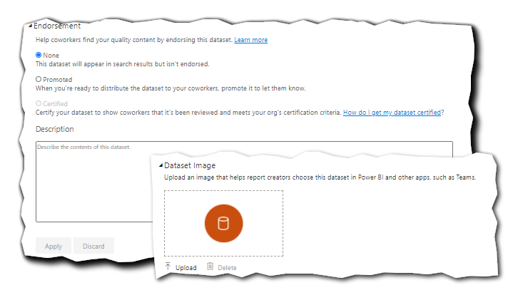

**Report**

1. Subscribe to your report pages. Open the report and create a subscription to the **Overview** page that sends a preview image and link to the report hourly. After creating the subscription, run the subscription immediately to test it.
2. Add two Pro licensed users as contributors to this workspace.
3. Invite the members to open the report and start a conversation using comments feature

**Dashboard**

1. Open the report, and pin the marked visuals to **2013 High Sales Region** dashboard. Q&A box should be visible on this dashboard.
2. Add “**What is the total sales amount by color?**” and “**What is the total sales amount by city?**” featured questions to the dataset
3. Open the report, and pin the marked visuals to **2013 Key Metrics.** Q&A box should be off on this dashboard.

**App**

1. You want to distribute the content of the workspace – dashboards and report - to business users. Create an app.